How to Connect the OT1 Driver Mobile App with an SR4
The following instruction guide will walk through the process of connecting the OT1 Driver Mobile app with the SmartRecorder™ 4 (SR4).

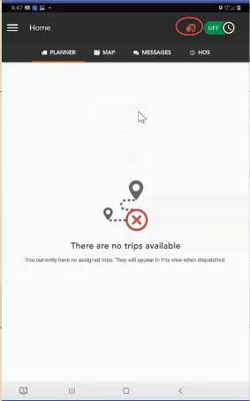
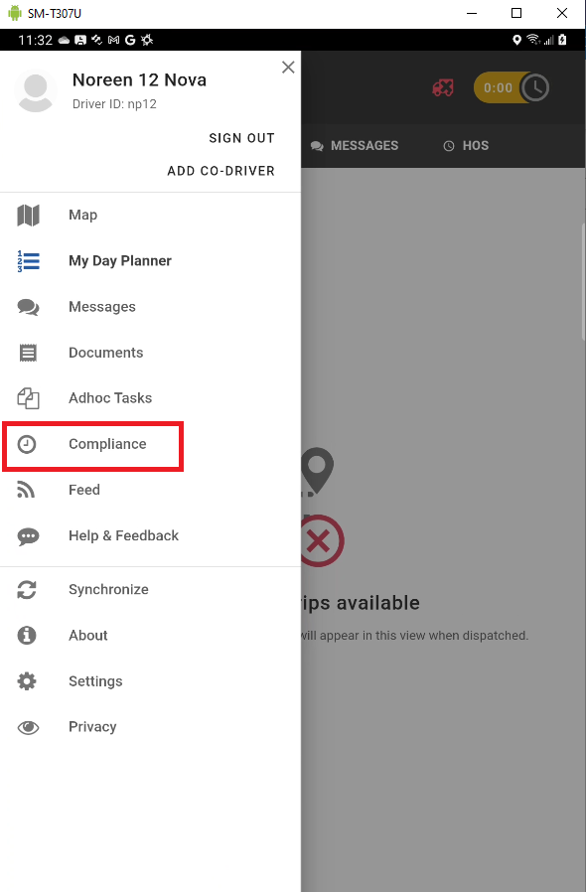
Connecting to a Vehicle with Cellular Cellular
Once you are Logged into the mobile you can connect to the SR4 by navigating to the Compliance app.

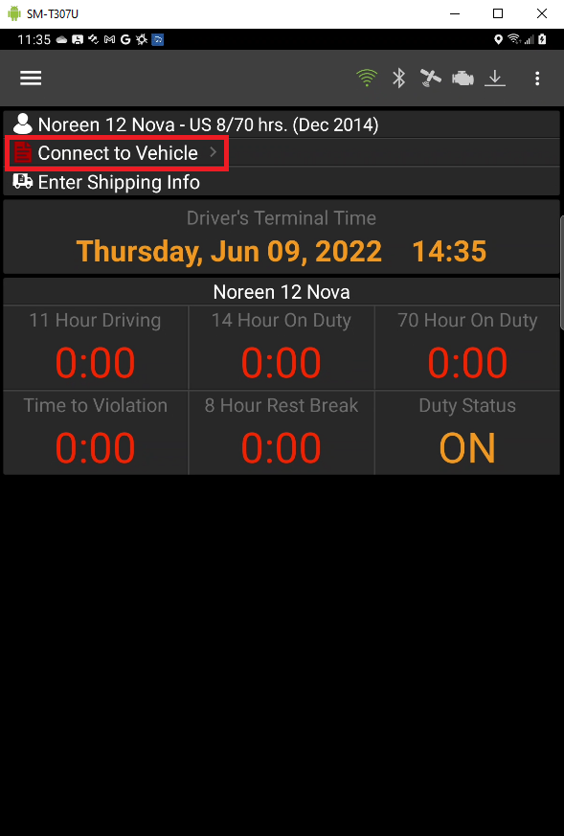
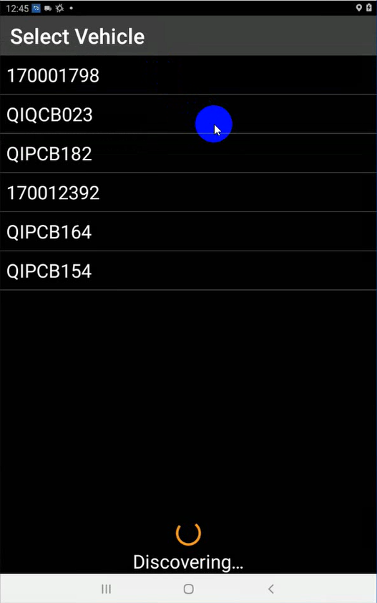
Select the Connect to Vehicle to display the Available equipment that can be connected. Select the correct device to connect.

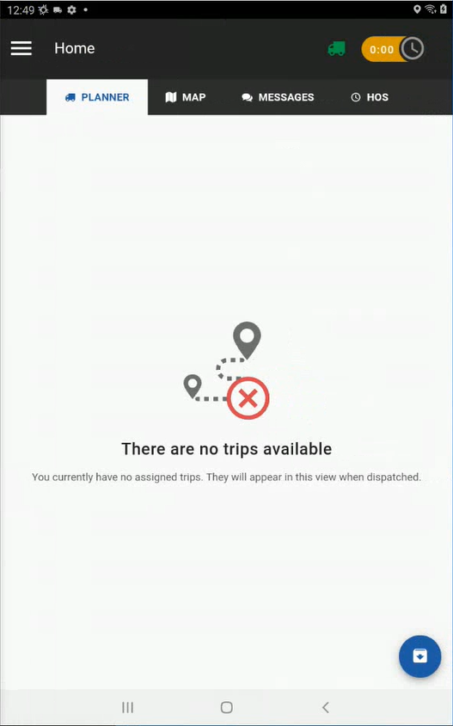
The vehicle will begin connecting.

Once you are connected to a vehicle the display
will be updated and reflect a green truck icon in the
top right corner.

Connecting to a Vehicle with Wi-Fi
Once you are Logged into the mobile you will need to connect to a New Vehicle. Select New Vehicle to continue.

Available equipment that can be connected will display. Select the correct vehicle to connect.

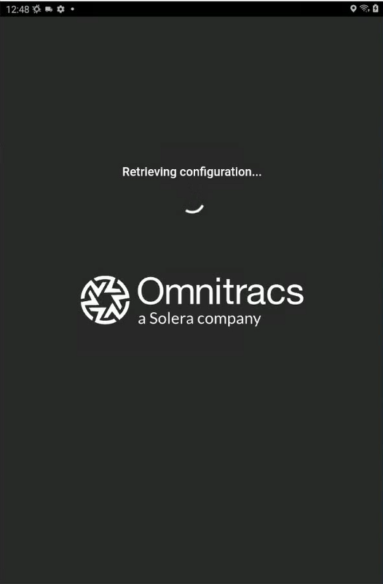

The vehicle will begin connecting.

Once you are connected to a vehicle the display will reflect a green truck icon in the top right corner.

