SmartDrive (SR4) Universal Install Guide
Last revised: 5/24/2022 (Version 1)

Contents
Overview 2
Vehicle assignment procedure 2
SmartDrive Core and Optional Components 6
Tools Required 7
Install the Sensor Bar 8
Install the Controller 8
Wiring 10
How to bypass a Master Power Cutoff (MPC) or Low Voltage Disconnect (LVD) 14
Tech App Section 14
Using the SmartDrive Technician Self-Check (Diagnostics Mode) 15
SR4 Installation Checklist and Diagnostics 19
SmartDrive Technician Diagnostics Mode Fault Codes 21

Overview
The SmartRecorderTM 4 (SR4) System captures and stores exception-based videos of your vehicles and drivers on the road. The SR4 is triggered by unsafe accelerations, excessive speeds, and manual activations. When triggered, the system provides a comprehensive view about what caused the event by recording multiple videos, audio, and vehicle movement.
The system automatically sends the events to SmartDrive’s expert review center for analysis and presentation to the fleet supervisor.
The system consists of a SmartRecorder4 Controller, Sensor Bar, and Cellular connections. The kit includes all necessary parts such a brackets, cables, and a wiring harness.
This guide provides instructions to install the SmartRecorder 4 System and provides technical details for troubleshooting.
SmartDrive Systems, Inc. reserves the right to void warranty if installation techniques are not followed. This guide is intended for experienced automotive installers that are trained in current, generally accepted, industry standards.
Please consult your SmartDrive Program Manager or Customer Service (1-866-933-9930, Option 1) prior to removing, swapping, or moving SmartRecorder 4 or cameras from any vehicle. Never install a SmartRecorder 4 in a vehicle unless SmartDrive has authorized and provisioned the SmartRecorder 4 to that vehicle.
The information contained herein is strictly confidential and is supplied exclusively to SmartDrive customers with the understanding that this information will be held confidentially and not disclosed to third parties without the prior written consent of SmartDrive Systems, Inc.
SmartDrive, the SmartDrive Logo, SmartDrive Safety, and SmartRecorder 4 are registered trademarks or trademarks of SmartDrive Systems. All other brands and product names are trademarks or registered trademarks of their respective owners. Information supplied by SmartDrive is believed to be accurate and reliable. SmartDrive Systems assumes no responsibility for any errors in this document. SmartDrive Systems reserves the right, without notice, to makes changes in product design or specifications.

Vehicle assignment procedure
The below steps will walk you through performing a new vehicle assignment, assigning a vehicle to another location, and adding a new vehicle as required.
Response Center Login: https://secure.smartdrive.net/login from this screen, you will enter your login credentials that were provided
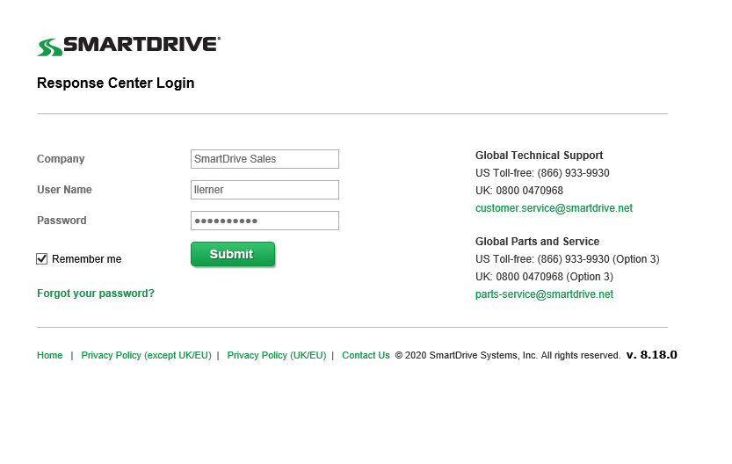
Go to the “Admin” section from the menu and select the ‘Vehicles’ tab, be sure to check ’Include child sites in search results’ and UNCHECK the ’Show active vehicles only’. In the ‘Enter a vehicle or SmartRecorder’ field and hit GO.
Note: If the vehicle is not found, proceed to the Adding a vehicle section in this document or you can search by Vehicle ID. Ensure you include any spaces that are in the Vehicle ID.
Note: a particular vehicle may exist only once in any given site, but the vehicle may be duplicated otherwise. Example: Site A may have one existence of vehicle 8887, but vehicle 8887 may exist in both the Site A and Site B.
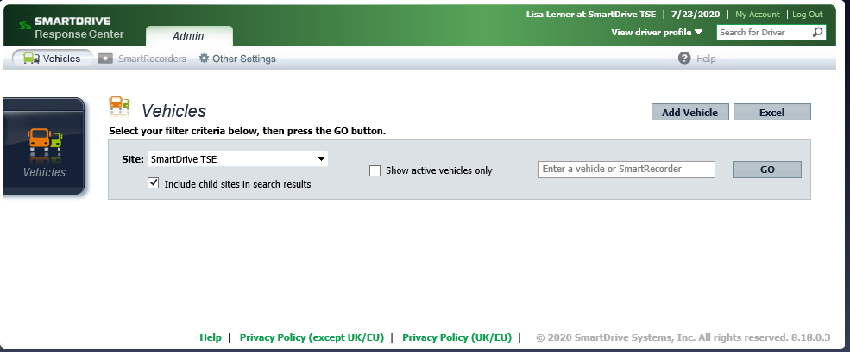
To locate a vehicle, begin typing the Vehicle ID in the search field, if there, it will pop up like in the example below. Click on the Vehicle ID to display your vehicle.
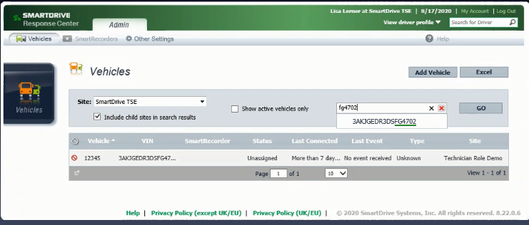
Once you see the vehicle, it will appear in the box below, click on the vehicle.
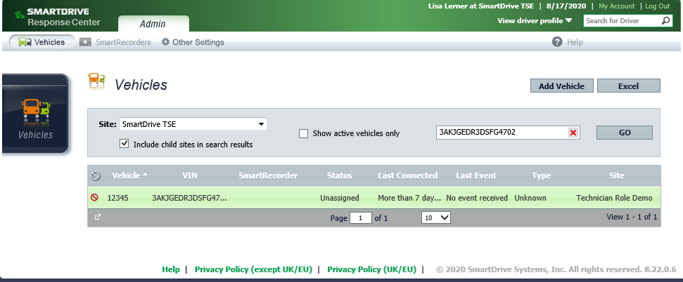

A pop-out screen will appear like below. Under the SmartRecorder field type is the serial number of the Controller that is going to be or was installed in the vehicle
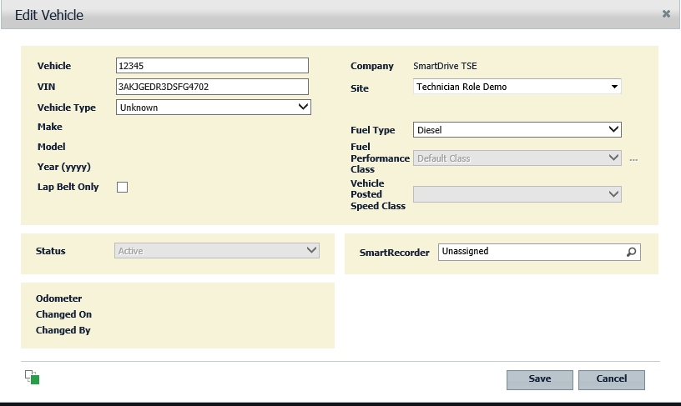

Note: By clicking the magnifying glass icon, all unassigned SmartRecorders at this vehicle’s current site will be listed. If the target SmartRecorder is at a different site, you will need to first move the SmartRecorder to that site and save. Then reselect the Vehicle and assign the desired SmartRecorder. After the SmartRecorder has been assigned, the Vehicle may be moved to its desired site. When a Vehicle with an assigned SmartRecorder is moved to a new site, the SmartRecorder is automatically moved with the vehicle.
Once you have selected your SmartRecorder, click ‘Save’ to associate the SmartRecorder.
If the Vehicle requires a site move, select the new Site name from the ‘Site’ dropdown .
Adding a Vehicle:
From the Vehicles tab, select ‘Add Vehicle’
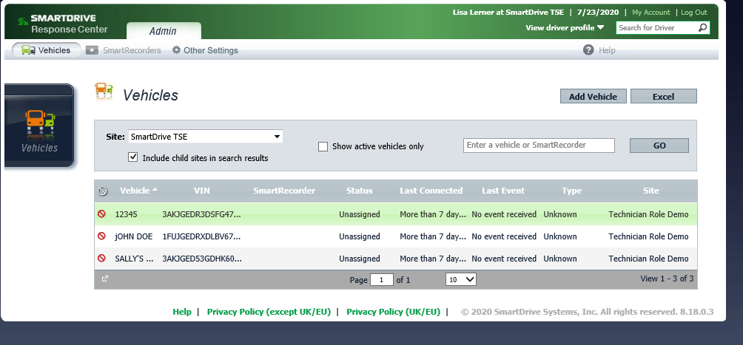

Once the pop-out box appears, you will need to make sure you are assigning the vehicle to the appropriate site. You can do this by hitting the down arrow where Site appears to expose all the sites for your company. Click on the site you wish to associate the vehicle to, then select ‘Save’.
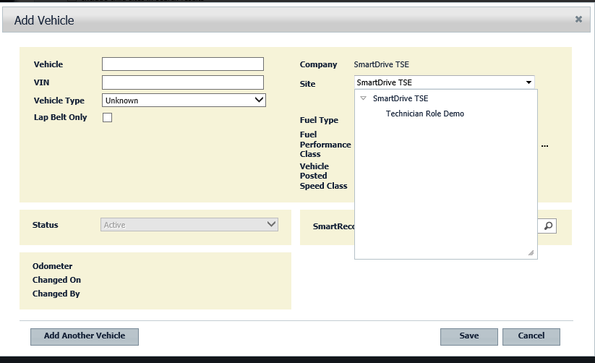
Fill in all the vehicle information
- Vehicle number/name in the ‘Vehicle’ field
- Vehicle Type
  - Please pick the vehicle type closest to yours from the drop-down list
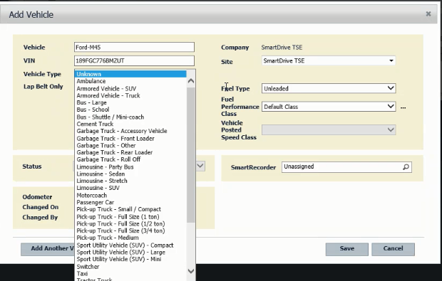

Note: It is not necessary to fill in the fields on the right side of the screen

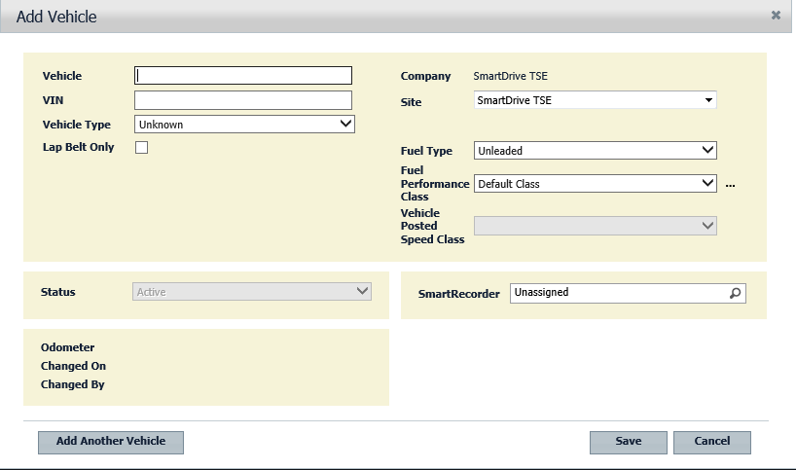

Next, you will follow the above instructions to locate the appropriate SmartRecorder to be or is installed in this vehicle and then hit Save.

SmartDrive Core and Optional Components
The SmartRecorder 4 system consists of the following components:
Core Components
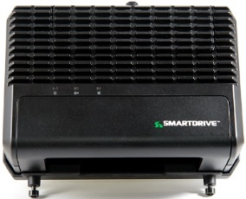 | SR4 Controller
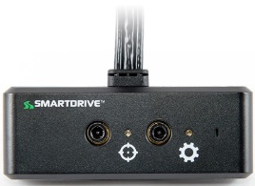 | Sensor Bar  (Cellular & Wi-Fi)
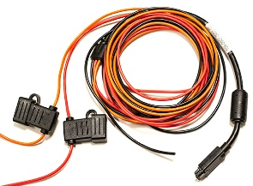 | Hardwire  Wiring Harness

Tools Required
To install the SmartRecorder 4 system, you will need the following tools:
SmartDrive Stock
- M4 Proprietary wrench
- Cable Removal Tool (which available in each controller)
- Rubbing alcohol swabs
- SmartDrive proprietary zip ties
Van Stock Supplies
- Zip ties (various lengths, 20 cm and 30 cm are the most common)
- 3m 33+ Electrical Tape
- 13 mm in length Phillips Pan Head self-tapping Screws
- Star Washers
- Flat Spade, Fork, and Ring, #8 - #10 connectors for 16-gauge wire
- 6mm split loom
- Add a circuit – Add a fuse adaptors
- Spare 5 amp fuses
Power Tools
- Digital Multimeter
- Cordless drill and charger with multiple batteries
- Head lamp or flash light
Hand Tools
- Quality wire crimping tool (Snap-on, Mac, Craftsman, Klein)
- Wire stripper/Ratchet stripper multi-gauge (Snap On, Mac, Craftsman, Klein)
- Flush cutting snips
- Proprietary SmartDrive M4 security wrenches
- Phillips/Torx/Allen and flat head bits or drivers
- Panel puller tool
- Various pliers
- Combination wrench set
- Razor knife (utility knife)
- Skew-driver - right angle drill attachment
- Assorted sockets – 6mm and 10mm deep well socket sets
- Tape measure
- Wisk broom
- Windshield scraper
- 25mm plastic putty knife
- Fish tape
- Small pocket level

Install the Sensor Bar
- Use an alcohol prep pad to clean the mounting surface and dry with a clean cloth prior to sticking the sensor.

- The Sensor Bar must be mounted on the windshield either vertically or horizontally
  - Acceptable vertical locations
    - 1 inch from the vehicle’s A-pillar and about 3 to 4 from the bottom of the dash
    - 1 inch from the vehicle’s A-pillar and about 3 to 4 from the top of the windshield
  - Acceptable horizontal locations
    - 1 inch below the top of the windshield

- Route the sensor cable to the controller through an agreed upon path (e.g. behind the vehicles A-pillar)
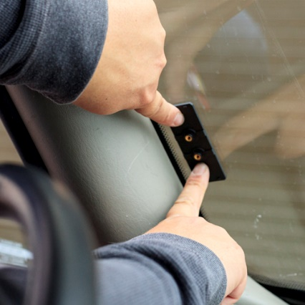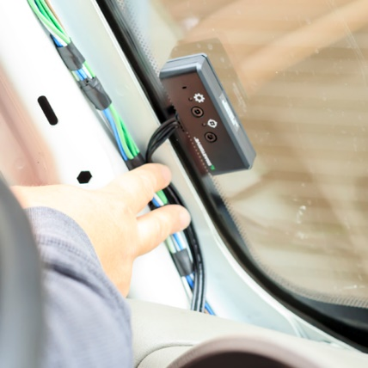

Install the Controller
- Remove the mounting bracket from the main Controller using the SmartDrive security wrench provided.
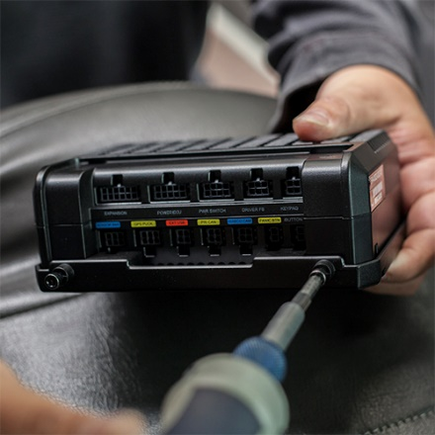

- Mount the bracket to a secure location inside or under the dash using SmartDrive proprietary zip ties or screws.
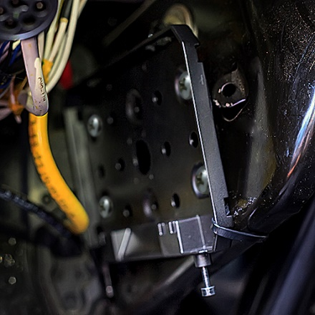
Important: Make sure that the bracket is mounted so that when the controller is placed into the bracket, the heat sink is NOT facing down.

- Insert the Sensor Bar cable into the slot labeled Sensor Bar on the side of the controller.
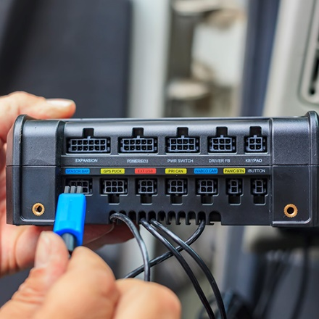

- Insert the Cellular cable into the slot labeled Cell Ant and Wi-Fi cable into the slot labeled Wi-Fi Ant
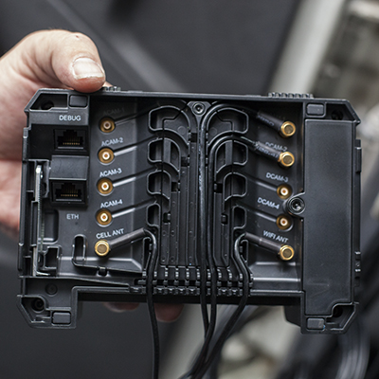
NOTE- always connect the Wi-Fi cable even if the customer only uses the cellular package.

- Place the Controller on top of the mounting bracket using the tabs located on the side for proper alignment.

- Screw the two M4 screws into the Controller using the SmartDrive security wrench.
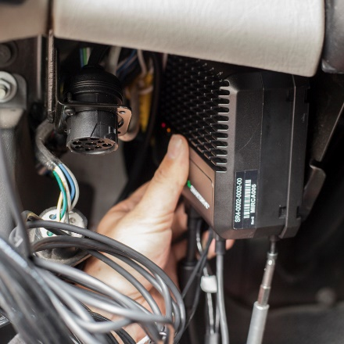

Wiring
The wiring harness includes the following components:
- True Ignition wire (orange)
- Uninterrupted Constant Power wire (red)
- Chassis Ground wire (black)
- Molex Connector connects to SmartDrive’s SR4TM Controller
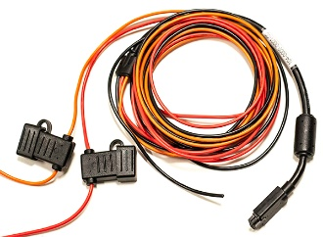
True Ignition
Wire (orange)

Molex
Connector
Chassis Ground
Wire (black)
3
4
Uninterrupted Constant Power
Wire (red)
2
1

Constant Un-Interrupted Power: SmartDrive harness RED wire
- The red wire (5 amp fused constant power lead) is connected to a constant power source
- Locate the constant 12v or 24v DC (depending on the system voltage) power source
- Connect the red wire (5 amp fused constant lead power) to an uninterrupted constant power source
- Test for constant 12v or 24v DC with the ignition ON/ OFF and while the starter is cranking - cranking -- the wire will have power all the time regardless of the key position
- Location could be Key Cylinder, power distribution center, under the hood or batteries

Locations:
1. Power distribution center / fuse panel
2. Vehicle Battery
3. Key Cylinder

Methods of power connections
- Bus bar or screw connections

Testing Uninterrupted Constant Power
The power wire is the constant [12V/24V (+)] wire and must be connected to a circuit that always has power regardless of the key position.
You can check this with a meter by connecting your black lead to Chassis Ground and the red lead to what you believe to be constant 12 volts. It will not lose current in the start or run key position.
If the SmartRecorder is not powered, check to see if the fuse has been blown. If the fuse has been blown, the cause must be ascertained and corrected. Also, refer to the next section on Master Power Cutoff for additional details on constant power.
True Ignition wire connection: SmartDrive harness Orange wire
The True Ignition wire (Orange) is connected to a true ignition source. A true ignition source is a circuit that is energized during the starter cranking process.
Get approval from the authorized onsite mechanic or vehicle manufacturer for acceptable wire connections.
- Use a Digital Multi Meter (DMM) to find the switched power source. With the ignition OFF, you should read 0v DC. Turn the ignition ON and you should read 12v or 24v DC (depending on the system voltage).
- Turn the key to the run position and verify that this is a true ignition source (not accessory) by making sure the voltage does not zero out during the starter cranking process.
- Switch the ignition OFF and check for no residual voltage.
- Connect the ignition wire to the true ignition power source only using approve connection methods

How to locate True Ignition with a Digital Multi Meter (DMM):
- With the vehicle off your meter will show zero volts
- With the key in the Run position your meter will show 11 to 14 volts
- With the vehicles starter cranking your meter will show 9 to 11 volts
- With the vehicle running your meter will show 12 to 24 volts
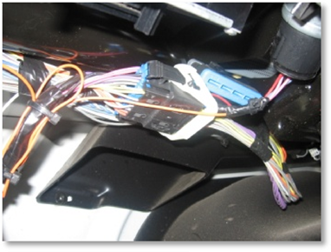

Testing True Ignition
Test an ignition wire by completing the following steps:
- Set your multi-meter to V DC
- Connect the black lead to chassis ground (-)
- Connect the red lead to the ignition wire
  - It should show 0 volts while the key is Off
- Cycle the key through the Run and Start positions
  - The multi-meter should show 12 or 24 volts in both positions
- Crank and run the vehicle while watching the multi-meter
  - Voltage should never drop below 7 volts during cranking
- If the multi-meter is displaying power while cranking, you have found a TRUE Ignition source. If it does not pass all three readings, select a different wire and start at Step A.
- Switch the ignition OFF and check for no residual voltage

Chassis Ground: SmartDrive harness BLACK wire
The ground connection is very important for reliable operation of the SmartRecorder™ system, therefore we recommend that you avoid grounding to the dash and avoid support brackets, under dash brackets, glued unibody panels, and isolated chassis components.
Check to see that the black wire is grounded to a
- Ground terminal
- Metal part of the vehicle’s body
The painted surface must be scraped prior making the connection. Use a star washer to make a solid connection and check the crimp on the ring terminal.
There are three ways to connect Chassis Ground
On Light-duty Vehicles
- Terminal Ring to chassis
On Heavy-duty Vehicles
- Connection to a power distribution/fuse panel
- Connection to a battery
Do – Follow the aftermarket electronics industry installation practices while sourcing through the vehicle’s chassis ground. Remove the paint before grounding (if painted)
Do not – Use removable panels for ground point
Use a star washer and self-tapping screw to connect the black wire to ground terminal or chassis ground (remove vehicle paint before attaching the self-tapping screw)
Approved Connection Methods
#10 Ring Terminal
- Attach a #10 ring terminal to the wire
- Gently tug on the connection to verify a solid crimp connection
- Secure the terminal to one of the following:
- Bus bar
- Terminal Block
- Chassis (ground only)
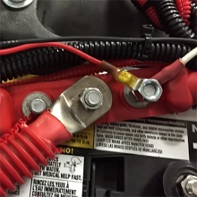

Spade Terminal
- Find the fuse box
- Identify the fuse type
- Connect spade terminal
  - Crimp the spade terminal and pull slightly to ensure a solid crimp
- Use the appropriate spade terminal size which matches the wire gauge
- Use the wiring diagram in the fuse box to identify an appropriate fuse slot
- Place the spade terminal into the fuse slot

Add-a-fuse
- Find the fuse box
- Identify the fuse type
- Connect the pigtail to the wire harness using a water resistant, heat-shrinkable butt connector
- Use the appropriate butt connector size which matches the wire gauge
- Use the wiring diagram in the fuse box to identify an appropriate fuse slot
- Place a fuse in the add-a-fuse slot parallel to the pigtail wire
- Insert the add-a-fuse into the fuse slot
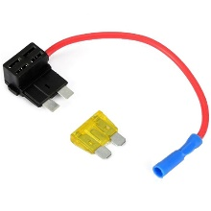

How to bypass a Master Power Cutoff (MPC) or Low Voltage Disconnect (LVD)

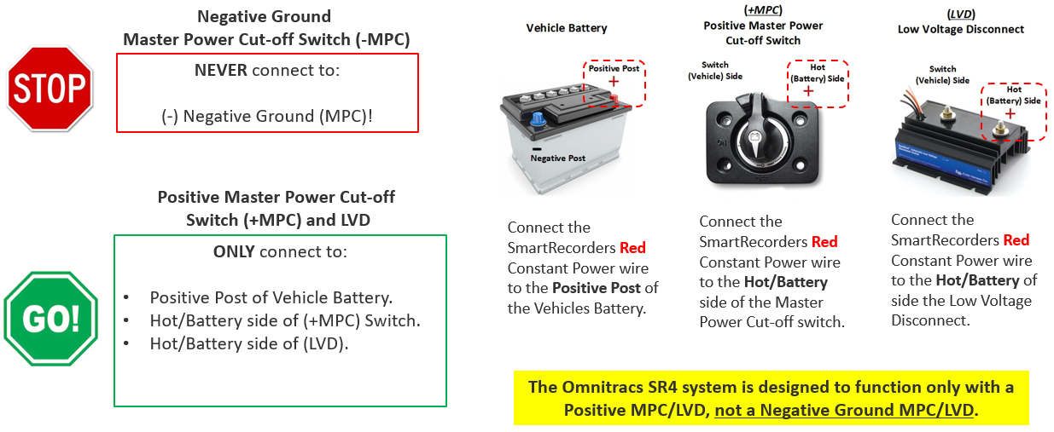
Overview/Explanation
- The SmartRecorder 4 system requires constant, uninterrupted power. This will ensure that power loss events do not occur.
- When the MPC switch is off, the SmartRecorder 4 will not be able to download and install updates that are pushed to the unit at night.
- Excessive power loss events to the SmartRecorder 4 can cause damage to the controller box over time.

Basic Installation Instructions
- Connect SmartDrive power harness red wire to the hot/live side of the vehicle battery or positive side of the master power switch.
- Connect the SmartDrive power harness black wire to the negative side (Ground Earth) of the battery or the negative side of the master power switch.

Tech App Section
Launching SmartDrive Technician:
      - Locate the SmartDrive Technician icon in your Android devices apps folder.
      - Select the Technician icon to launch the application.

Connecting to a SmartDrive Controller
SmartRecorder Search | Connection Screen | Camera List | Connect
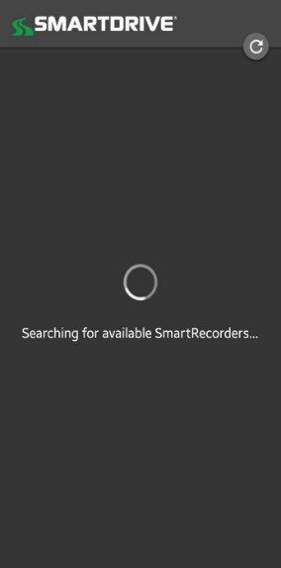 | 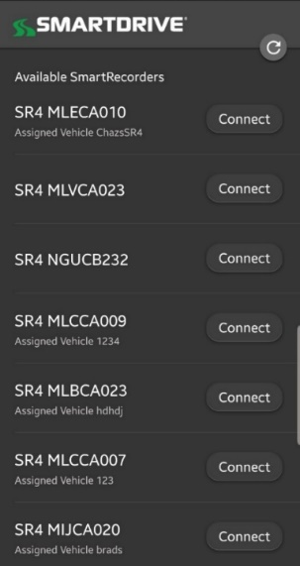 |  | 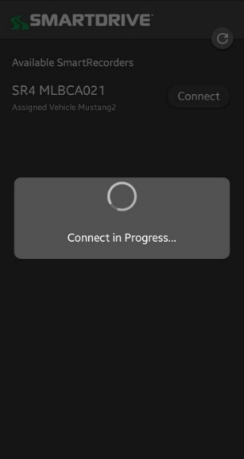
After starting the App, it will automatically begin searching for any SR4 controller within a 30ft range. | All SR4 controllers will broadcast their serial number and connection for up to 5 minutes when the vehicles ignition is on.  If the installed SR4 serial number is not found, cycle the vehicles ignition “off,” then back “on”, then select the refresh button to begin a new search.  When you find the correct SR4 serial number, press connect. |  | The App will connect to the controller.

Using the SmartDrive Technician Self-Check (Diagnostics Mode)
The following instruction guide will walk users through using Self-Check for diagnosing technical issues with the (SR4) SmartRecorder™ 4 system.
Requirements:
- The Smart Technician application will only function on Android devices with Bluetooth capability running Android version 5.0 or higher and is not compatible with PC or IOS devices.
- The application will only operate with the SmartDrive (SR4) SmartRecorder™ 4 system and is not compatible with the SmartDrive (SR3) SmartRecorder 3 system.

Device Settings:
- Ensure your device is Bluetooth capable and the Bluetooth connection is turned on.
- Verify the “Location” setting on the Android device is turned on as well.

- Note: The app will not properly function if these setting are not enabled on your device.

Launching Application:
- Locate the SmartDrive Technician icon in your Android devices apps folder.
- Select the Technician icon to launch the application.

Login Page:
- The App will automatically begin searching for any (SR4) controller within a 30ft range.
- All (SR4) controllers will broadcast their serial number and connection for up to 5 minutes after the vehicles ignition has be cycled on.
- If the installed (SR4) serial number is not found, cycle the vehicles ignition “off,” then back “on”, then select the refresh button to begin a new search.
Connection Screen
SmartRecorder Search

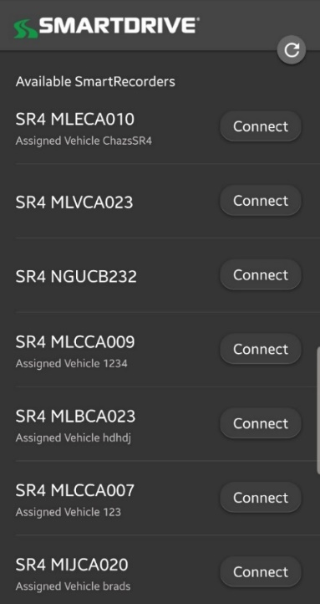

- Once the desired (SR4) controller serial number is located, select “Connect” to login.
Connection Progress Screen
Connection Screen

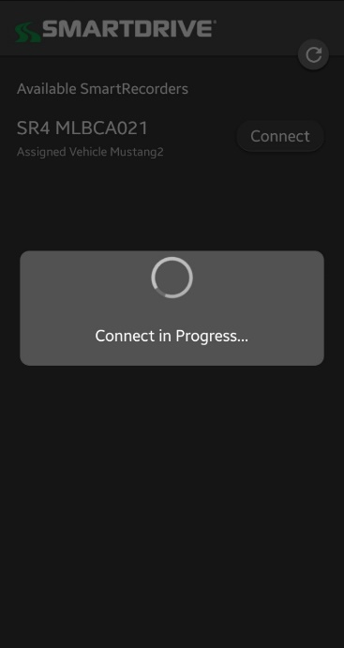

Run Self-Check
The Self-Check (Diagnostic Mode) is an environment that runs a set of tests on the (SR4) SmartRecorder™ 4 in order to identify any faults that may be occurring. It takes approximately four minutes for the SR4 to run a self-diagnostic check and up to 12 minutes to completely reboot the system. Please note that events will not be recorded while the system is running the Self-Check.

- Access to the Self-Check (Diagnostic Mode) can be found under the “Run Self-Check” section.
- To run the Self-Check (Diagnostic Mode):
  - Cycle the vehicles ignition to the “ON” position and wait approximately 10 seconds.
  - With the vehicles ignition still in the “ON” position, select “Run Self-Check”.
  - The Self-Check will immediately begin checking the SR4’s status.

Select Run Self-Check
Self-Check is Processing

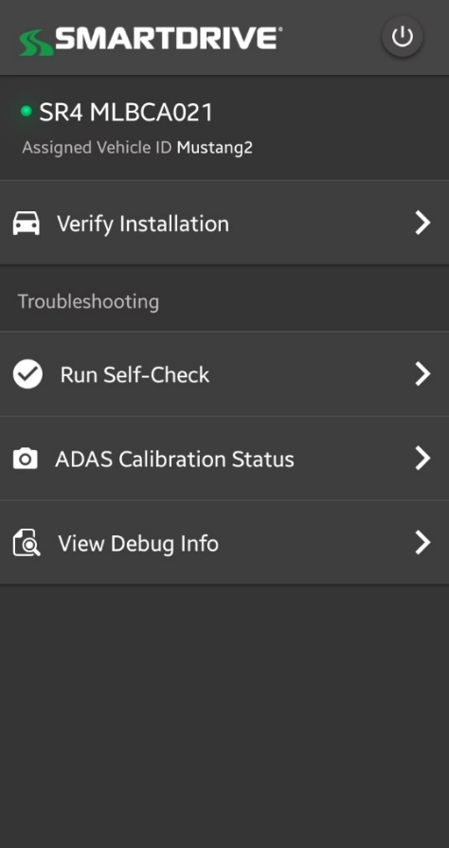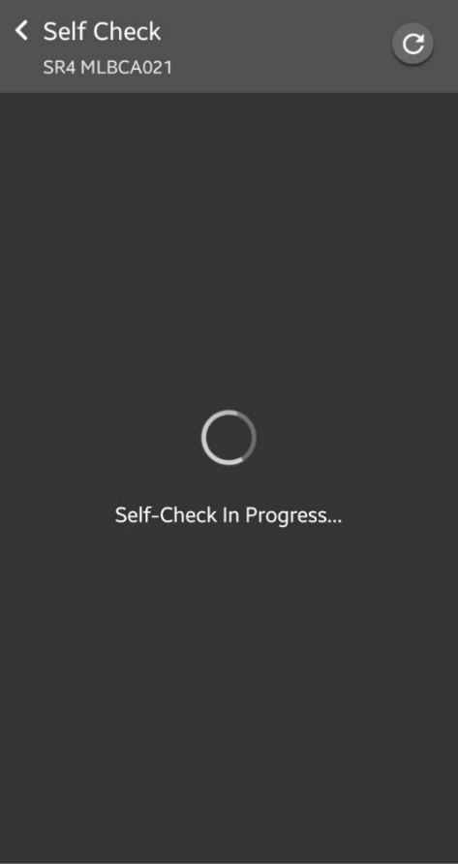

  - Once the Self-Check is complete, it will display the results in the format below.

Self-Check result with NO Errors  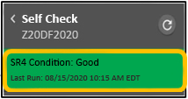 | If no errors are present, the application will display a GREEN alert at the top of the page displaying the condition of the SR4 as “good.”  Scroll down on the page to view the state of each system check.  The Self-Check will display a passing result under each system check.
Self-Check result WITH Errors  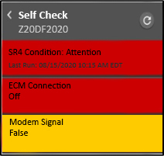 | If any errors are found, the application will display a RED alert at the top of the page displaying the condition of the SR4 as “Attention.”  Scroll down on the page to view the state of each diagnostic check.  The diagnostic error will be highlighted in RED or YELLOW.  The color RED indicates a critical issue that affects the systems functionality requiring immediate attention.  The color YELLOW indicates a less critical issue that may have a lower impact on the systems functionality.

SR4 Combined Install Checklist-Fault Codes Guide
This document is available for your use. Ask management to download you a copy from SmartDrive’s help page on their web site called the Response Center.
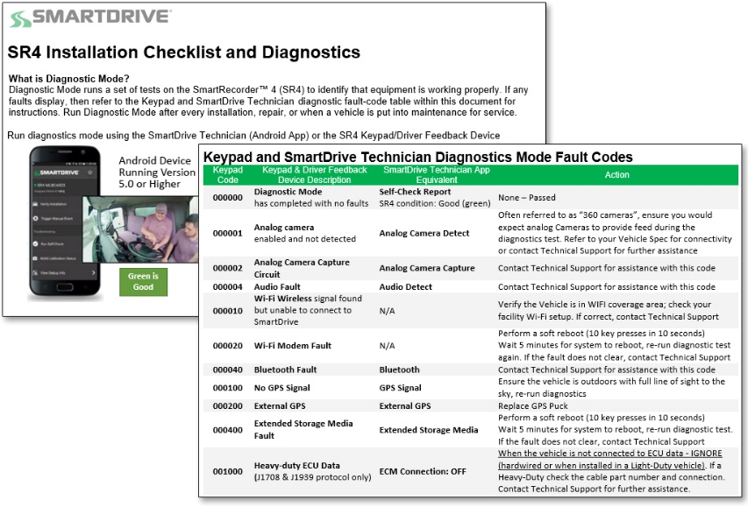

SR4 Installation Checklist and Diagnostics

What is Diagnostic Mode?
Diagnostic Mode runs a set of tests on the SmartRecorder™ 4 (SR4) to identify that equipment is working properly. If any faults display, then refer to the SmartDrive Technician diagnostic fault-code table within this document for instructions. Run Diagnostic Mode after every installation, repair, or when a vehicle is put into maintenance for service.
Run diagnostics mode using the SmartDrive Technician (Android App)

SmartDrive Technician Method
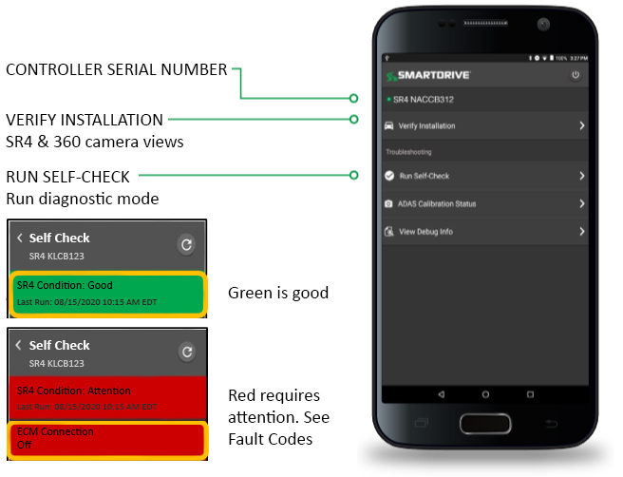 | Download the App  - Go to: play.google.com/store/apps  - In the search bar type: SmartDrive Technician  - Click Install  Easy to Follow Installation QA Process  - Complete the SmartRecorder Installation using the SmartDrive Installation Guide  - Open the Technician App via your Android device (Bluetooth transmits for 5 minutes after ignition is turned on)  - Locate the controller serial number within the App and select to connect  - Select RUN SELF-CHECK to start diagnostics mode to check failure/warnings  - Resolve all error codes. All green is good. If you have errors, refer to fault codes section for instructions.
Get help from SmartDrive Technical Support
If you need assistance resolving a fault code, contact SmartDrive Technical Support for assistance.
- US QA at 866-933-9930 (Option 4)
- U.K. QA at 0800-047-0968 (Option 4)
- EU at +44 800 047 0968 (Option 4)

SmartDrive Technician Diagnostics Mode Fault Codes
Code | Description | SmartDrive Technician App Equivalent | Action
000000 | Diagnostic Mode  has completed with no faults | Self-Check Report  SR4 condition: Good (green) | None – Passed
000001 | Analog camera  enabled and not detected | Analog Camera Detect | Often referred to as “360 cameras”, ensure you would expect analog Cameras to provide feed during the diagnostics test. Refer to your Vehicle Spec for connectivity or contact Technical Support for further assistance
000002 | Analog Camera Capture Circuit | Analog Camera Capture | Contact Technical Support for assistance with this code
000004 | Audio Fault | Audio Detect | Contact Technical Support for assistance with this code
000010 | Wi-Fi Wireless signal found  but unable to connect to SmartDrive | N/A | Verify the Vehicle is in WIFI coverage area; check your facility Wi-Fi setup. If correct, contact Technical Support
000020 | Wi-Fi Modem Fault | N/A | Perform a soft reboot (10 key presses in 10 seconds)  Wait 5 minutes for system to reboot, re-run diagnostic test again. If the fault does not clear, contact Technical Support
000040 | Bluetooth Fault | Bluetooth | Contact Technical Support for assistance with this code
000100 | No GPS Signal | GPS Signal | Ensure the vehicle is outdoors with full line of sight to the sky, re-run diagnostics
000200 | External GPS | External GPS | Replace GPS Puck
000400 | Extended Storage Media Fault | Extended Storage Media | Perform a soft reboot (10 key presses in 10 seconds)  Wait 5 minutes for system to reboot, re-run diagnostic test. If the fault does not clear, contact Technical Support
001000 | Heavy-duty ECU Data  (J1708 & J1939 protocol only) | ECM Connection: OFF | When the vehicle is not connected to ECU data - IGNORE (hardwired or when installed in a Light-Duty vehicle). If a Heavy-Duty check the cable part number and connection. Contact Technical Support for further assistance.
002000 | Cab Facing Camera  enabled but not working | Driver Facing Camera | Indicates an issue receiving video from the cab-facing camera. Inspect the camera; confirm the cable is plugged completely into D-CAM 2 connection on the controller.
004000 | Forward Facing Camera  enabled but not working | Road Facing Camera | Indicates an issue receiving video from the road-facing camera. Inspect the camera; confirm the cable is plugged completely into D-CAM 1 connection on the controller.
010000 | Ignition currently off | Ignition | The ignition of the vehicle was OFF during the Diagnostic Test. Verify ignition is ON and re-run diagnostics. If the error returns confirm the connection is true ignition
020000 | Sensor Bar not found | Sensor Bar Detect | Reseat the sensor bar connection to the Controller. Replace Sensor Bar or contact Technical Support for further assistance
040000 | Sensor Bar fault | Sensor Bar Work | Critical sensor bar fault (includes GPS chip failure) Re-seat the sensor bar connection to the Controller. Replace Sensor Bar or contact Technical Support.
100000 | Configure Settings | Configure Setpoints Checksum | Perform a soft reboot (10 key presses in 10 seconds). Wait 5 minutes for system to reboot, perform diagnostic test again  If fault does not clear, contact Technical Support
200000 | Cellular Wireless signal not found | Modem Signal (Cellular wireless signal not found) | The controller cannot establish a network connection. Often due to the vehicle being in a location, that does not have good cellular coverage. Move the vehicle to an area that has good coverage and re-run diagnostics.
400000 | Cellular Modem Fault | Modem Detect (Cellular modem detect | Perform system reset & re-run diagnostics. if code isn’t cleared replace the controller & contact Technical support

