SR4 SmartDrive Technician User Guide

Downloading and Installing the SmartDrive Technician App
The following instruction guide will walk through the requirements for Smart Technician application, downloading and installing the Smart Technician application, along with a brief explanation of the basic application features.

Requirements and Settings:
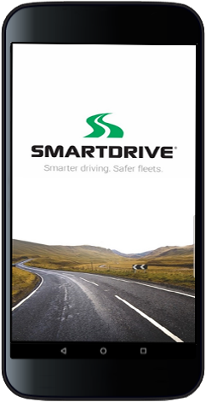
Technical Requirements:
- The Smart Technician application will only function on Android devices with Bluetooth capability running Android version 5.0 or higher.
- The app is not compatible with PC or IOS devices.

Android Device Settings:
- Bluetooth and Location services on must be is turned on.
Note: These settings must be enabled for the App to function properly.

Downloading and Installing App:
Download the App:
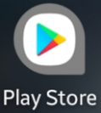
- Go to play.google.com/store/apps or launch the Google Play Store from you Android device.
- In the search bar type: SmartDrive
- Select the SmartDrive Technician from the list
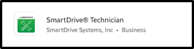
  - Click Install

Launching the App:

Application Set-up:
- Once the installation is complete, select “Open” to launch the App.
- Enable Technician to Access photos, media, and documents.
- Read and Accept the Terms and Conditions.

Documentation and Support:
Additional documentation and user guides for each feature of the Technician application are also available.
- SmartDrive Technician – Camera Alignment User Guide
- SmartDrive Technician – Self-Check Diagnostic User Guide

Get help from SmartDrive Technical Support
- U.S. 866-933-9930 (Option 4)
- U.K. 0800-047-0968 (Option 4)
- EU +44 800 047 0968 (Option 4)

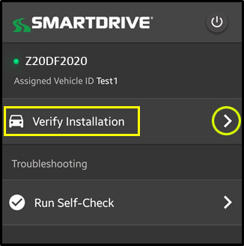
SmartDrive Technician
The following instruction guide is a step-by-step guide for using the SmartDrive Technician application to perform a functionality check of the SmartRecorder™ 4 (SR4).

Launching SmartDrive Technician:
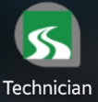
      - Locate the SmartDrive Technician icon in your Android devices apps folder.
      - Select the Technician icon to launch the application.

Connecting to a SmartDrive Controller
SmartRecorder Search | Connection Screen | Connect | Connecting
 | 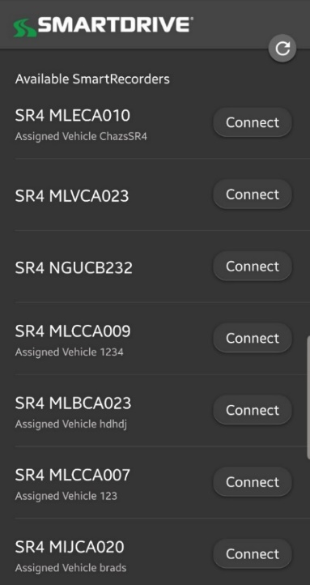 |  | 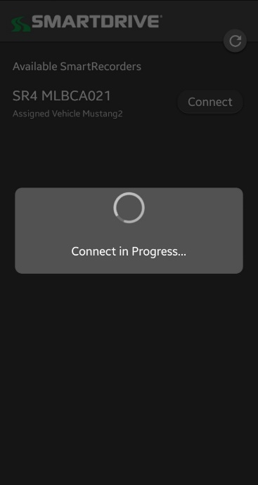
After starting the App, it will automatically begin searching for any SR4 controller within a 30ft range. | All SR4 controllers will broadcast their serial number and connection for up to 5 minutes when the vehicles ignition is on.  If the installed SR4 serial number is not found, cycle the vehicles ignition “off,” then back “on”, then select the refresh button to begin a new search.  When you find the correct SR4 serial number, press connect. |  | The App will connect to the controller.

Verify Installation:
Once logged into the (SR4) controller, the user will see the Landing Page.
Select “Verify Installation” to access the Service Options.

Getting Started
The “What are you working on today?” section offers component selections.

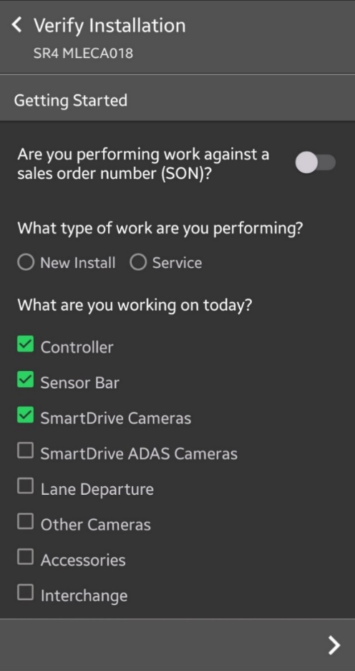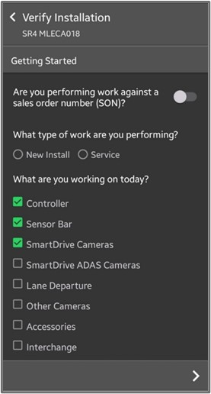
Next Page

- After making your selections, proceed to the next page by selecting the arrow at the bottom right of the screen.

Self-Check (Diagnostics Mode)

Run Self-Check
The Self-Check (Diagnostic Mode) is an environment that runs a set of tests on the (SR4) SmartRecorder™ 4 in order to identify any faults that may be occurring. It takes approximately four minutes for the SR4 to run a self-diagnostic check and up to 12 minutes to completely reboot the system. Please note that events will not be recorded while the system is running the Self-Check.

- Access to the Self-Check (Diagnostic Mode) can be found under the “Run Self-Check” section.
- To run the Self-Check (Diagnostic Mode):
  - Cycle the vehicles ignition to the “ON” position and wait approximately 10 seconds.
  - With the vehicles ignition still in the “ON” position, select “Run Self-Check”.
  - The Self-Check will immediately begin checking the SR4’s status.
  - If the (SR4) SmartRecorder™ 4 system is equipped with a SmartDrive Keypad or Driver Feedback Device (DFD), the word “Test” will be displayed on either device confirming the Self-Check is processing.
Self-Check is Processing
Select Run Self-Check

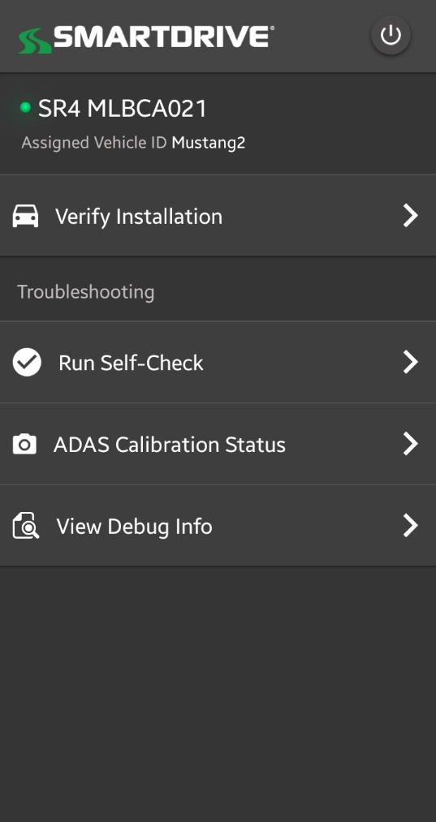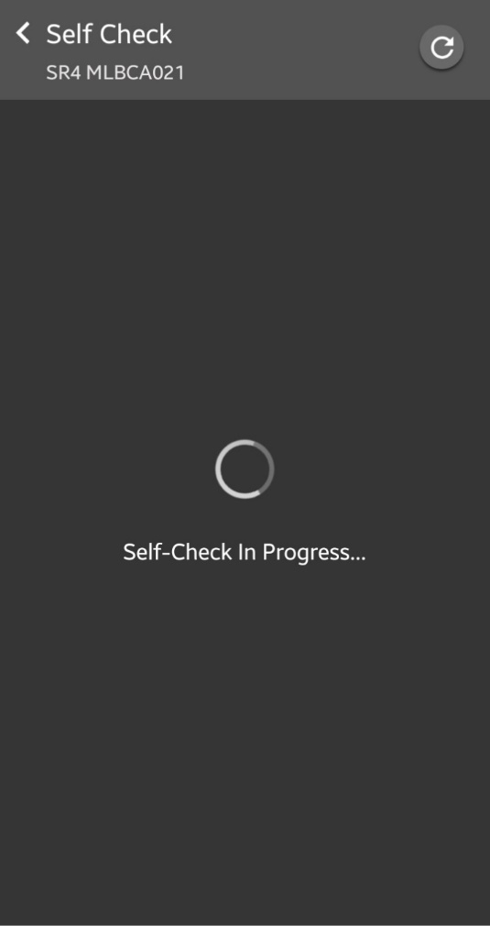

  - Once the Self-Check is complete, it will display the results in the format below.

Self-Check result with NO Errors  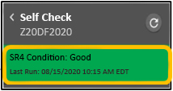 | If no errors are present, the application will display a GREEN alert at the top of the page displaying the condition of the SR4 as “good.”  Scroll down on the page to view the state of each system check.  The Self-Check will display a passing result under each system check.
Self-Check result WITH Errors  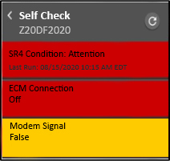 | When an error occurs, the application will display a RED alert at the top of the page displaying the condition of the SR4 as “Attention.”  Scroll down on the page to view the state of each diagnostic check.  The diagnostic error will display RED or YELLOW to highlight the condition.  The color RED indicates a critical issue that impacts the systems functionality requiring immediate attention.  The color YELLOW indicates a less critical issue that may have a lower impact on the systems functionality.

SR4 Combined Install Checklist-Fault Codes Guide
This document is available for your use. Ask management to download you a copy from SmartDrive’s help page on their web site called the Response Center.
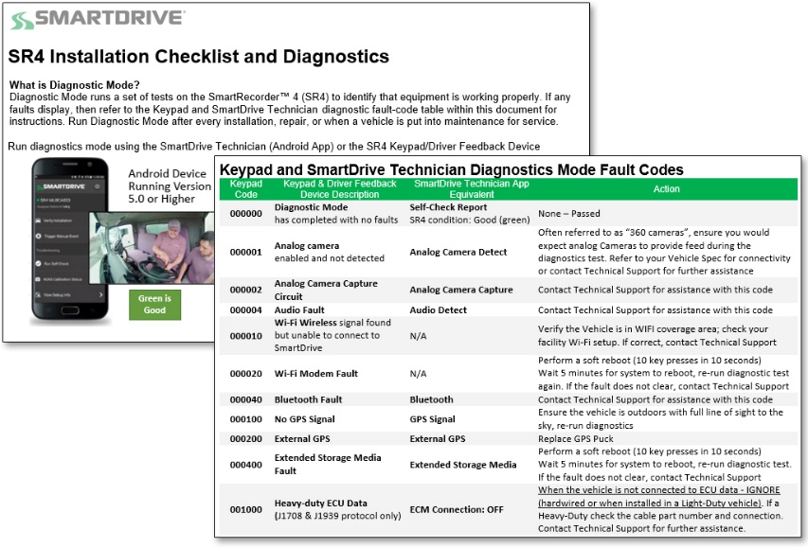

Wiring Check feature
Improper connections between the SR4 and vehicle wiring can lead to improper SR4 operation. By example, the SR4s ignition wire should be connected to true ignition, but on occasion the installer may connect the ignition wire to Accessory. A check for proper wiring in the SmartDrive Technician aids installers and troubleshooters to verify that the wiring is correct.
Wiring Check is available both via the main menu and from within the Verify Installation workflow

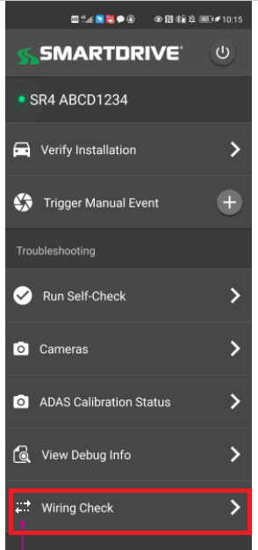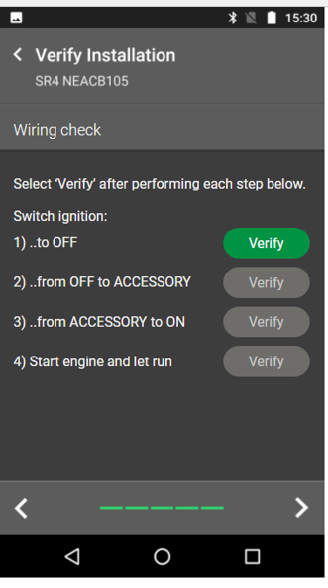

To run the wiring check the installer should make all required connections from the SR4 to the vehicle then follow the 4-step wiring check process pictured below. The process involves cycling the ignition through 4-stages during which the application assess whether the wiring is correct at each stage. The user verifies each stage by selecting the “Verify” button on the screen.

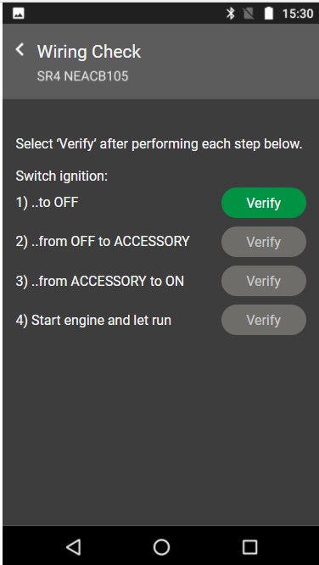
The application will display an error message with directions when any stage of the wiring check finds an error. The user should then correct the wiring and select “Re-verify” to rerun the stage of the wiring check with the error.

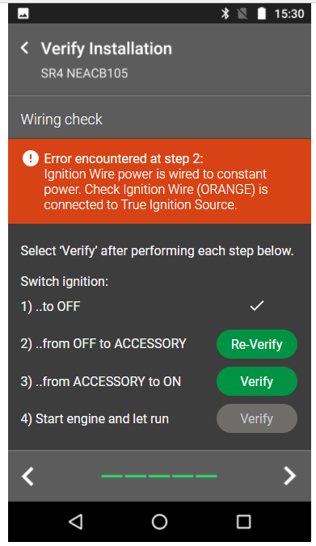

A message is given to the use upon all four stages of the wiring check passing validation.

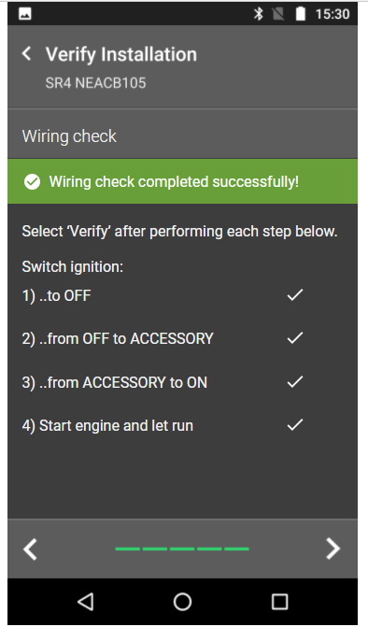

Inattentive Sensor Calibration Feature
The Inattentive Sensor system includes two cameras
- A monochrome camera that uses computer visions to identify certain distractions such as cell phone usage and inattention such as drowsiness.
- A color inward facing wide-angle camera to capture the vehicle interior.
The monochrome or Sensor camera requires calibration at the time of installation so that the system is equipped to recognize where the driver’s head is to perform its sensing.
A new menu item has been added to the verify installation workflow named “SmartDrive DBC Camera”. Note: In a future release, “DBC Camera” will be renamed to “Sensor Camera.”

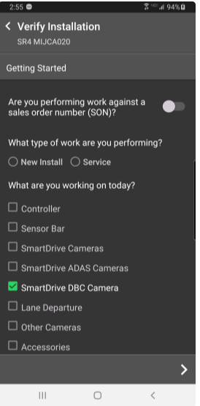

Logging Out
- To logout from SR4 controller by selecting the power icon at the top right corner of the screen.
- Select “LOGOUT” when prompted.
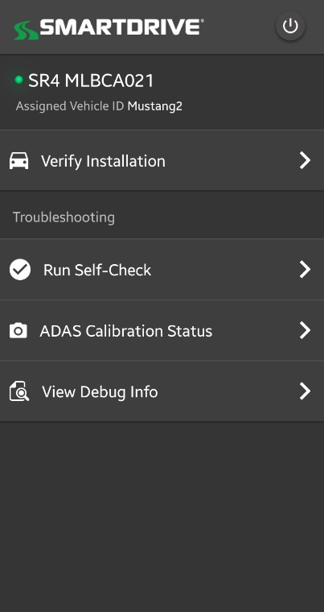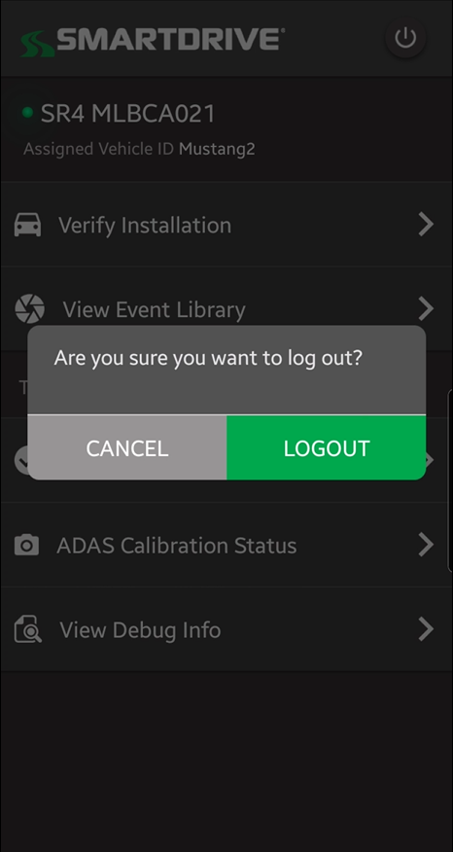

SmartDrive Technician Application Errors
- The Technician App may experience errors or issues due to hardware issues or environmental factors.
- If the applications experiences any issues and displays error messages, use the following chart below to troubleshoot
Error – Unexpected Disconnect  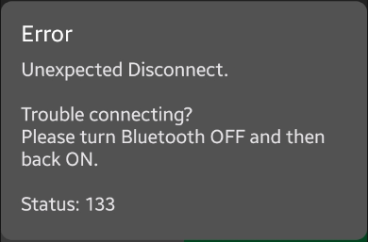  Error – Connection Timeout  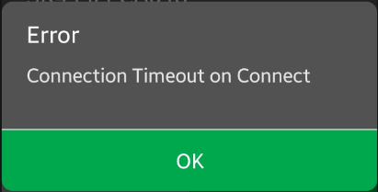 | Reason: Bluetooth connection timed out or Bluetooth connection was lost  Steps:  - Re-log back into the SR4 if prompted.  - If step 1 does not resolve the issue, cycle the Bluetooth on the Android device On/Off, then attempt to re-log back into the SR4.  - If step 2 does not resolve the issue, perform a soft-reset to the SR4 controller. Once the SR4 system has fully booted back up, re-log back into the SR4.
Error – Connection Interrupted  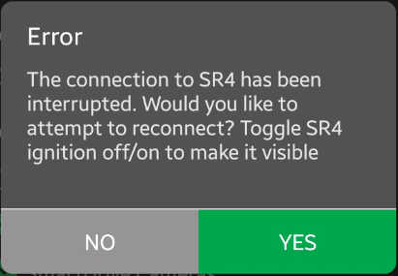 | Reason: Bluetooth Connection was Interrupted  Steps:  - Attempt to re-log back into the SR4 by selecting “Yes”.  - If step 1 does not resolve the issue, verify if the controller is re-booting. If the controller is re-booting, let the system reboot, then re-log back into the SR4 once the SR4 system has fully booted back-up.  - If the SR4 is NOT rebooting, cycle the Bluetooth on the Android device On/Off, then attempt to re-log back into the SR4.  - If step 3 does not resolve the issue, perform a soft-reset to the SR4 controller. Once the SR4 system has fully booted back up, re-log back into the SR4.
Error – Please, try again later | Reason: An unknown error has occurred.  Steps:  - Simply refresh the page by selecting the re-scan button at the top right of the page, and then re-test the camera.  - If refreshing the page does not resolve the issue, restart the Smart Technician application, and then re-test the camera.  - If re-starting the application does not resolve the issue, perform a soft reset on SR4 controller, then re-test the camera once the system has rebooted.
Error – Generate Image On Camera | Reason: Image generation has timed-out due to the system not being ready.  Steps:  - Simply refresh the page by selecting the re-scan button at the top right of the page, and then re-test the camera.  - If refreshing the page does not resolve the issue, restart the Smart Technician application, and then re-test the camera.
Error – Initiate Bluetooth File Sharing | Reason: Bluetooth connection has timed-out due to a system error.  Steps:  - Simply refresh the page by selecting the re-scan button at the top right of the page, and then re-test the camera.  - If refreshing the page does not resolve the issue, restart the Smart Technician application, and then re-test the camera.  - If re-starting the application does not resolve the issue, perform a soft reset on SR4 controller, then re-test the camera once the system has rebooted.

Additional Support
For additional troubleshooting support or questions, please review the SmartRecorder 4 Troubleshooting Guide located in the Help section of the SmartDrive Response Center or contact our SmartDrive Technical Support team at (866)-933-9930, Extension 4.

